Twitter Topic Summarization
Abstract:
In order to enable users to quickly view a summary about a topic searched , a system is proposed in which given an input query topic, the best relevant tweets are retrieved by the system using speech acts and from which the noise removal is done and then an abstract summary is formed. This requires the use of summarization algorithms from tweets and it also requires the formation of sentences based on information got from tweets.
Domain: Machine Leaning , Natural Language Processing
Problem Statement:
To build a system that helps to get a topic oriented summarization from tweets and gains information from them .In this system we plan on using basic speech acts like question, suggestion, comment, suggestion, miscellaneous to find the tweets containing information and using relevance between the tweets.

Applications:
It could be used to generate abstractive summaries for news articles , technical articles, and briefings.

Literature Review:
- Automatic Twitter Topic Summarization With Speech Acts [Renxian Zhang, Wenjie Li, Dehong Gao, and You Ouyang]
This paper proposes a speech act-based approach to Twitter topic summarization.The approach to topic summarization is employed in three Core modules : recognizing speech acts in tweets, extracting speech act-guided key words/phrases,and generating abstractive summaries

2.Sequential Summarization: a Full View of Twitter Trending Topics [Dehong Gao, Wenjie Li, Xiaoyan Cai, Renxian Zhang and You Ouyang]
Sequential summarization, which aims to provide a serial of chronologically ordered short sub-summaries for a trending topic in order to provide a complete story about the development of the topic while retaining the order of information presentation. Two approaches, i.e., stream-based and semantic-based approaches, are developed to detect the important subtopics within a trending topic. Then a short sub-summary is generated for each subtopic. In addition, we propose three new measures to evaluate the position-aware coverage, sequential novelty and sequence correlation of the system-generated summaries.

3. Comparing Twitter Summarization Algorithms for Multiple Post Summaries[David Inouye* and Jugal K. Kalita+]
In this paper , a Frequency based summariser (involving Sum Basic & hybrid TF-IDF) was proved to provide better results than the other 6 summariser’s used. Eight different summarizers :random, most recent, MEAD, TextRank, LexRank, cluster,Hybrid TF-IDF and SumBasic.A threshold was used to find out similarity.

Block Diagram:
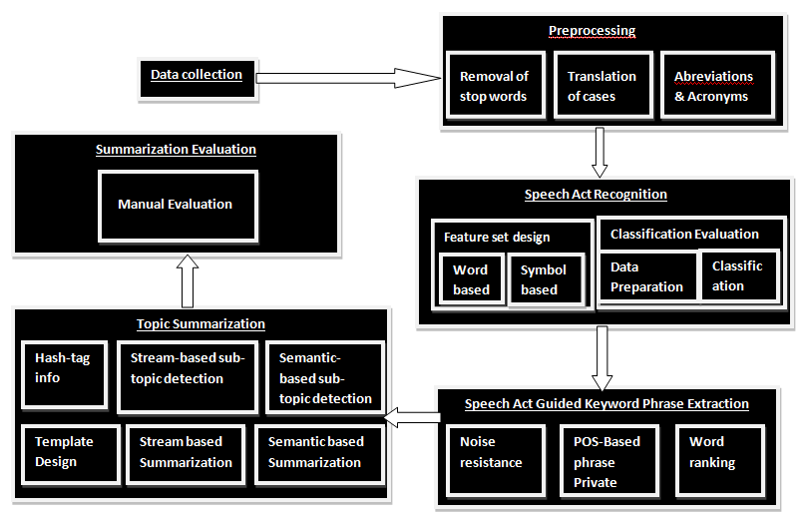
References:
- Automatic Twitter Topic Summarization With Speech Acts [Renxian Zhang, Wenjie Li, Dehong Gao, and You Ouyang]
- Sequential Summarization: a Full View of Twitter Trending Topics [Dehong Gao, Wenjie Li, Xiaoyan Cai, Renxian Zhang and You Ouyang]
- Comparing Twitter Summarization Algorithms for Multiple Post Summaries[David Inouye* and Jugal K. Kalita+]
- TweetMotif: Exploratory Search and Topic Summarization for Twitter
- Automatic Summarization of Twitter Topics
Beaux Sharifi, Mark-Anthony Hutton and Jugal Kalita
University of Colorado at Colorado Springs

System Design:

1)Data Collection:
Using Twitter Api to get the tweets which are used for our Topic Summarisation

2)Preprocessing
a)Removal of Stop Words:
A module in which all the stop words are removed.
b)Translation of cases:
A module in which all words are translated into lower cases for better results.
c)Abbreviations and acronyms:
A module in which abbreviation of all acronyms which are used in social networking sites like im,4ever etc is done.
3)Speech act Recognition
Feature Set Design:
A module in which all the features which are required to classify between the different speech acts.
a)Word based features:
eg:Question:What,Who ,Why etc..
Getting the word based features on the speech acts
b)Symbol based features:
?-Question and !
Classification Evaluation:
a)Data Preparation
A suitable data set for a supervised classification algorithm is used.
b)Classification:
A module in which tweets are classified in each topic using different feature sets employing SVM algorithm.

4)Speech act guided keyword/phrase extraction
a)Noise Resistant Phrase Extraction
In this module we try to extract key words and phrases from the tweets of major speech act types. Extracting the key phrases is
formulated as finding frequent n-gram collocations.
b)POS based Phrase Extraction:
Statements are about facts, things, people, etc. and suggestions are about actions, activities, etc. Such information can be approximated by part-of-speech (POS) patterns for both words and phrases.
c)Phrase/Word Ranking
A module in which we assign a rank to a phrase and see its importance.

5)Topic Summarisation:
a)Hash tag info:
Apply a method to use hash tag for information related to the topic by splitting it up .
b)Stream-based subtopic detection:
The stream-based subtopic detection then is to identify these peak areas from the tweet stream about a specific topic.
c)Semantic-based subtopic detection:
-To identify subtopics from the semantic perspective, semantic-based subtopic detection could be done by a kNN method or another equivalently efficient algorithm to capture subtopics in the tweet stream.
d)Template Design:
Insert the information so far gathered and putting them in slots of a basic template .
e)Stream based sequential summarization algorithm:
A summarization algorithm is used to summarize all the sentences so far extracted from the text based on local relevance, global relevance and crowd endorsement by using a cosine similarity formula.
f)Semantic based summarisation algorithm:
We use the output probabilistic relationships between tweets and subtopics to assign each tweet to the subtopic that it most likely belongs to. Then the subtopics are ordered by the mean timestamp
of the tweets in the corresponding subtopics. A score is computed for each sentences from the corpus collected and selected .Then the tweets with the highest scores are selected for each subtopic. MMR is used to remove redundancy in the generation of each sub-summary in both cases. For each tweet to be selected into sub-summary, it is compared against the tweets that are already selected in the previous sub-summaries. The tweet is selected only when it is considered not significantly overlapping any previously selected tweets.

Final Work to be done:
Given a topic a user should view an abstract summary of the Topic.

